# Unit 6: Do we find goodness in power?



Figure 6.1. Image from <https://pixabay.com/en/child-cool-dress-fun-hero-red-164318/>. Shared under a Creative Commons license

## Overview

Are you a powerful person? Who do you have power over? How do you wield this power? And how do your power relationships impact the quality of your life? In this lesson, we will question whether power is an important contributor to the good life, whether power leads to goodness, and whether we would choose to be an underdog or an oppressed person. We will examine ourselves in light of the level of power we currently have or hope to have.

## Prompts

Unit 6 is divided into 2 prompts:

Prompt 1: The Ring of Gyges (Plato)

Prompt 2: The Milgram Experiment

## Learning Outcomes

Through practicing inquiry in this unit, you will:

* Examine and evaluate the nature of the relationship between power and goodness.
* Break down a classical allegory to discover answers to the question, “What is the good life?”
* Examine assumptions about power and question your own experiences
* Analyze and interpret a classical social experiment
* Analyze and synthesize various perspectives (from our class prompts and from classmates)
* Practice respectful listening to classmates and to the prompts
* Compare different notions of power as they relate to personal and social flourishing

## Activity Checklist

Here is a checklist of learning activities you will benefit from in completing this unit. You may find it useful for planning your work.

|  |  |
| --- | --- |
| 🗹 | **Activities** |
|  | Activity 6.1: Watch the video for “Do you hear the people sing” (*Les Miserables*). Journal your response |
|  | Activity 6.2: Take some time to think about the questions presented about power. |
|  | Activity 6.3: Review the background information about Plato’s The Ring of Gyges. |
|  | Activity 6.4: Read the story of The Ring of Gyges. |
|  | Activity 6.5: Watch the video of Pink Floyd’s “Another Brick in the Wall” |
|  | Activity 6.6: Read the background and details of the Milgram Experiment. Watch the recorded experiment (optional). |

**Assessment**

Here is the assessment for Unit 6.

|  |  |
| --- | --- |
| **Group discussion:** Do we find goodness in power?  Meet with your group and discuss what the Milgram Experiment shows you about power. | 2% |

## Prompt 1: The Ring of Gyges

The word “power” is hefty. You might think of the intensity of natural elements like water and fire, the might of superheroes, athletes, and everyday heroes, the people who hold positions of power, such as national leaders, bosses, coaches, and pastors. We use the word *powerful* to describe ideas, images, songs, words, and even tastes. We think of images of power, like “the corner office” and the “power suit” in modern times, or the scepter and staff in older days. Is power good? Can it be good? Plato invites us into these questions through his analogy known as “The Ring of Gyges.”

### Learning Activities

#### Activity 6.1: Les Miserables video and response

The story of *Les Miserables* follows the fate of the “underdogs” who do not have power as they try to revolt against those who are in power. Watch the [video](https://www.youtube.com/watch?v=gMYNfQlf1H8) for “Do you hear the people sing” (*Les Miserables*), a scene and song of revolution.

Next, take approximately 5 minutes to journal your thoughts in response to the following questions:

* In stories, who do you cheer for? The one who has power or the one who is subjugated?
* How do you respond when the “enslaved” person/people (or the underdog) gains power?
* Would you choose to be the one who is enslaved?

#### Activity 6.2: Power Questions

Take some time to contemplate the following questions before moving into today’s prompt.

* + Do we find goodness in power?
  + What does power mean to you?
  + How do people come to have power?
  + What are the benefits and risks of power?
  + Is there goodness in having power? Is there goodness being without power? Is it possible to have balance?
  + Should power be limited?
    - For an individual?
    - For a group?
    - For a nation?

#### Activity 6.3: Plato’s Republic

To engage in this lesson’s theme of power, we’re going to read a section of Plato’s Republic – Ring of Gyges. Before we get into the reading, review the background information below.

**Plato – Biographical Information**

* Citizen of Athens, Greece (ca. 427 BC – 347 BC)
* Given name was Aristocles.
* Plato is a nickname, perhaps referring to his broad shoulders.
* In 404 BC, at the end of Peloponnesian war, Plato turned down invitation to join those leading the oligarchy which replaced Athens’ democracy.
* This oligarchy, lead by the “Thirty Tyrants” only survived a year.
* During this same time Plato’s teacher, Socrates, publicly attacked the Athenian’s focus on wealth and physical beauty, promoting instead the importance of the mind.
* This conflict lead a trial in which the Athenians found Socrates to be a threat to their society, sentencing him to drink a potion of poison hemlock.
* Plato established an Academy, ca. 387 BC, which served as a place of higher education and communal living.
* The central instructional method preferred by Plato was person-to-person dialogue.
* This Academy continued to 529 AD, when it was closed by Roman Emperor Justinian the First because it was of pagan origins.

**Plato’s Republic (ca. 388-366 BC)**

* The original Greek title is “Politeia” – meaning a community of citizens, or constitution.
* It is an attempt to define a utopian society’s governing structures.
* Ethical leadership and justice are the central themes of the work.
* The use of Socrates as a central character in written dialogues is an homage to Plato’s teacher, through which he sought to record Socrates’ method and influence.

#### Activity 6.4: The Ring of Gyges

Read the story of The Ring of Gyges on the following slides **[insert link to Plato Slides]**.

In your learning journal, consider the following questions. Feel free to share with your group when you meet this week.

* What other stories does this remind you of?
* Would you like to have a ring similar to this? Why – Why not?
* What would you want to do if you had such a ring?
* What is your response to the shepherd’s actions?
* Do you agree that every person would be unethical, given the abilities of a ring of Gyges?
* Is it through the pressures of society that we choose to act justly, or through the strength of our own ethics?

*Note that as with all of the first lesson prompts, you will* ***not be graded*** *on these discussions. This prompt will help you explore the topics and will be instrumental in completing the final project.*

## Prompt 2: The Milgram Experiment

We hear stories in the news and in our social media feed – stories that make us ask, “Who would do something so despicable? How could a person be so inhumane?” We often struggle to understand the perpetrators of violent crime and bullying. Following the atrocities of World War II, Stanley Milgram wanted to find out how far ordinary people would go if they were asked to follow orders. As you spend time examining the experiment, think about times when you have been put in a difficult situation, perhaps faced with a decision to follow someone who had power over you in some way. Look for the threshold when the influence of power tips one way or the other.

### Learning Activities

#### Activity 6.5: Listen and Reflect

Watch the video of Pink Floyd’s [“Another Brick in the Wall”](https://www.youtube.com/watch?v=YR5ApYxkU-U) and look up the lyrics if you want to follow along.

Consider the social pressures and laws as they influence human behavior and whether we would all use power for our own good if we had it.

In your journal, consider social influences on power: government, education, religion, family, and economy. Does our society use power for goodness?

#### Activity 6.6: The Milgram Experiment

Read the background and details of the Milgram Experiment below. The historical context is very important to your analysis. If you would like to see the experiment itself, you can do an online search for various versions. [This recording](https://www.youtube.com/watch?v=mOUEC5YXV8U) of the experiment includes an explanation and shows exactly how the “teacher” was instructed.”

**Stanley Milgram**

* Stanley Milgram (1933-1984) was a Professor of Psychology at Yale University (1960-1963) and a Professor of Psychology at Harvard University, without tenure (1963-1984).
* His academic career focused on researching conformity
* Religious affiliation: Jewish
* Died of a heart attack

**The Milgram Experiment**

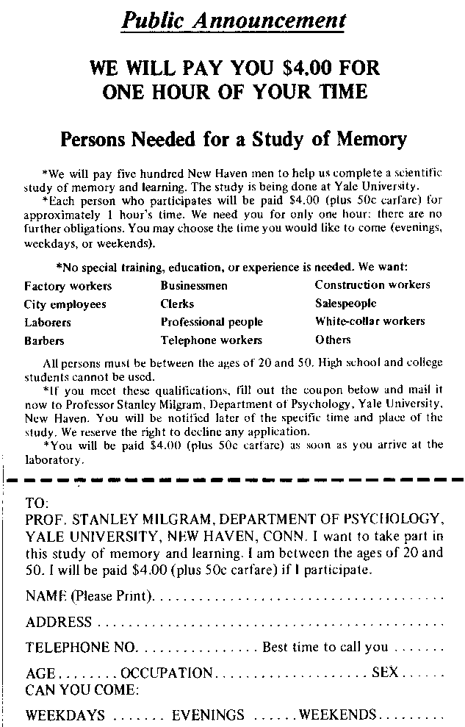

Figure 6.2: **[Insert caption and reference. Find CC version]**

* In 1960, Stanley Milgram conducted an experiment in social psychology to explore the limits to which people would subject themselves to authority. He was inspired by Adolph Eichmann’s war crime defense that he was merely “following orders”
* Unfortunately, this study is most notorious for having not received informed consent from the participants.
* Participants were either supervisors, learners or teachers. Supervisors and learners were trained in advance, and acted their parts as directed. Volunteers were the teachers and the focus of the experiment, and didn’t know that the other members of each team were actors.

The experiment progressed as follows:

* The Teacher and Learner draw slips of paper to determine roles (the outcome was rigged)
* The Teacher worked through a long series of multiple choice, word association questions with the Learner (now seated in a separate room).
* For each wrong answer, the Teacher was directed by the Supervisor to administer a shock to the Learner, who would respond as if receiving an electric shock.
* If Teacher was reluctant, the Supervisor directed the Teacher to continue.
* The experiment stopped if the Teacher refused to continue.
* If 315 volts was reached, the Learner (actor) was directed to scream loudly and then make no more sound.
* The apparent voltage of the shocks began at 15 volts would be gradually increased throughout the experiment to 450 volts.
* If the Teacher administered 3 shocks at 450 volts, the experiment was ended.
* Volunteers were told the truth about the experiment after their session.

**The Milgram Experiment - Results**

* The experiment was run 19 times, in different physical settings.
* 65% of those in the first version of the experiment proceeded to the 450 volt stage.
* When run in a typical office building, the results dropped to 47.5% continuing to the highest level.
* Inclusion of women did not change the results.
* By introducing a partner Actor-Teacher the results climbed to 90%.

## Assessment

### Group Discussion: Do we find goodness in power?

After completing this unit, including the learning activities, meet with your group to discuss what the Milgram Experiment means and how it can help us understand the place of power in the good life. Complete the Group Template and post it as a record of your discussion of Prompt 2.

## Unit 6 Summary

Perhaps you think of yourself at a distance from the concept of power. You may feel that you are not in any position of power. However, the prompts in Unit 6 have led us to probe the complexities of power and question our own experiences. We *are* in positions of power in some ways, perhaps as an older sibling, a more experienced employee, a leader on campus, a volunteer. We are also in positions under the authority of others. In this unit, we asked if and how our positions within power structures influence our measure of “the good life.”

## References

* King, William B. "Stanley Milgram." *Salem Press Biographical Encyclopedia*, January. EBSCO*host*, <http://search.ebscohost.com/login.aspx?direct=true&db=ers&AN=88827762&site=eds-live>.
* Lewis, Thomas Tandy. "Milgram Experiment." *Salem Press Encyclopedia of Health*, January. EBSCO*host*, <http://search.ebscohost.com/login.aspx?direct=true&db=ers&AN=93872104&site=eds-live>.
* Milgram, Stanley. "Behavioral Study of Obedience." *The Journal of Abnormal and Social Psychology*, vol. 67, no. 4, Oct. 1963, pp. 371-378. EBSCO*host*, doi:10.1037/h0040525.
* Plato. *The Republic*. Translated by Benjamin Jowett. e-book, pp. 235-236. Project Gutenburg, 2008. <http://www.gutenberg.org/ebooks/1497>
* Rickards, Bill. "Republic by Plato." *Salem Press Encyclopedia of Literature*, January. EBSCO*host*, <http://search.ebscohost.com/login.aspx?direct=true&db=ers&AN=87575252&site=eds-live>.
* Satris, Stephen. "Plato." *Salem Press Biographical Encyclopedia*, January. EBSCO*host*, <http://search.ebscohost.com/login.aspx?direct=true&db=ers&AN=88258842&site=eds-live>.
* Satris, Stephen. "Socrates." *Salem Press Biographical Encyclopedia*, January. EBSCO*host*, <http://search.ebscohost.com/login.aspx?direct=true&db=ers&AN=88258906&site=eds-live>.